**EXPERIMENT 6**

**Demonstrate virtualization by Installing Type-2 Hypervisor in your device, creating and configure a VM image with a Host Operating system (Either Windows/Linux).**

Step 1: Create a new VM

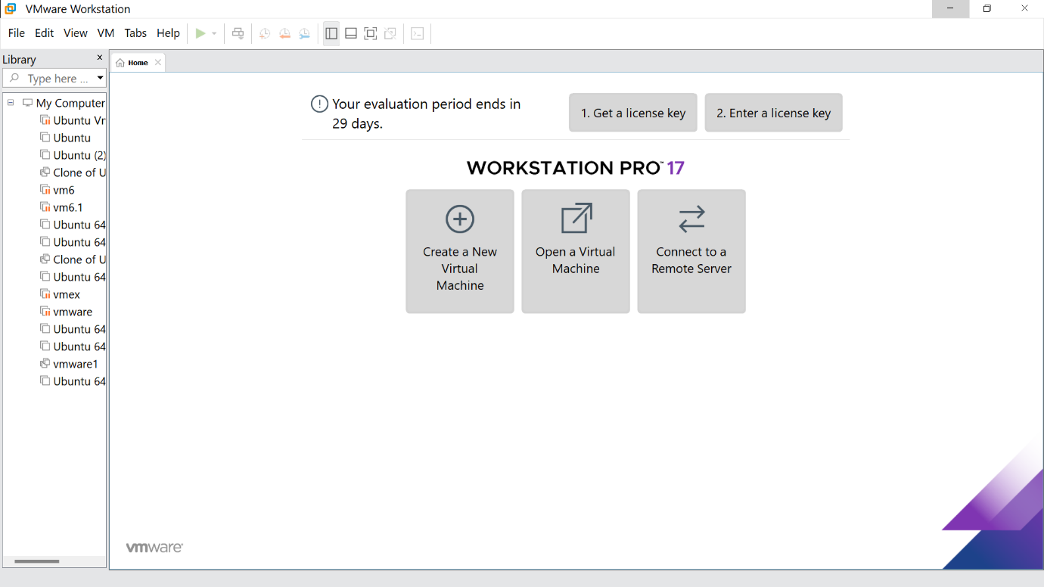

Step2: Click on Typical option and click Next

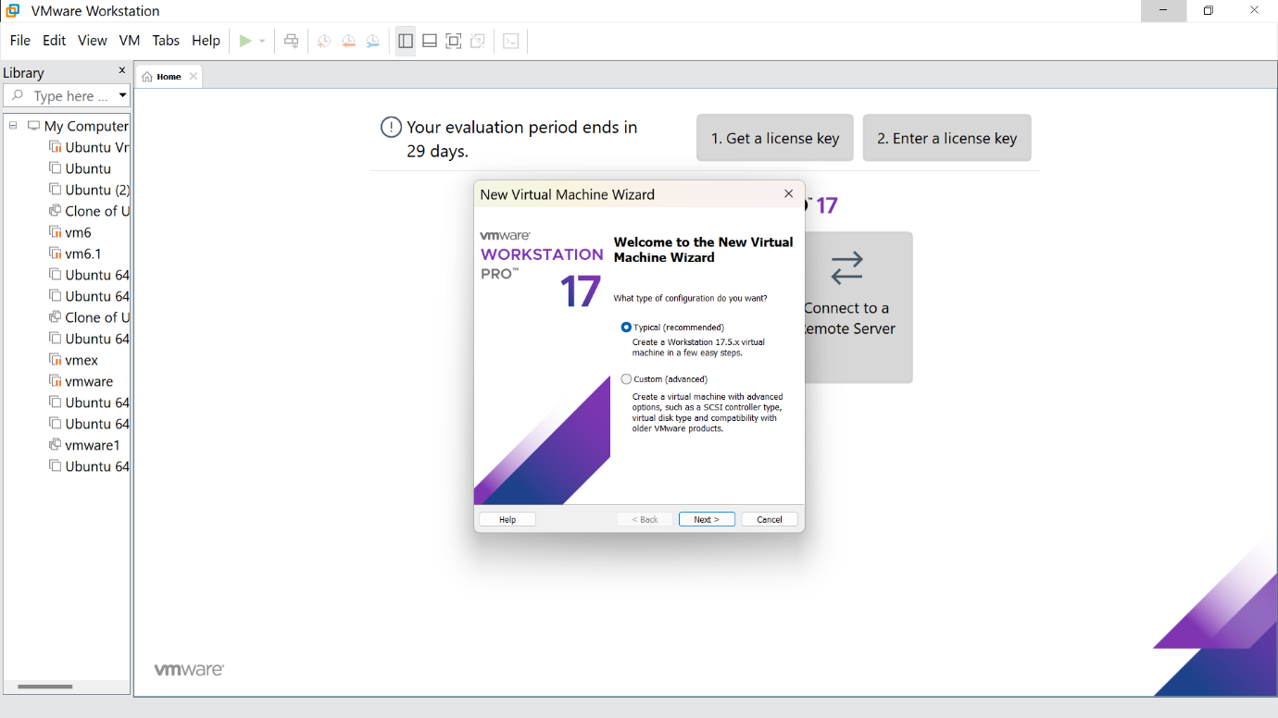

Step 3: Click on install and browse the file you need and click next

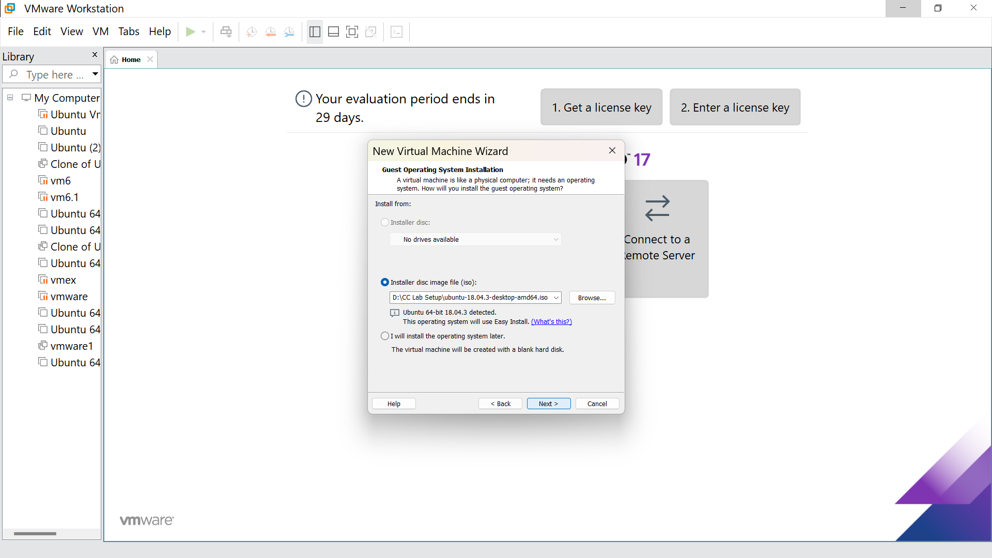

Step 4:Fill the following details and click next

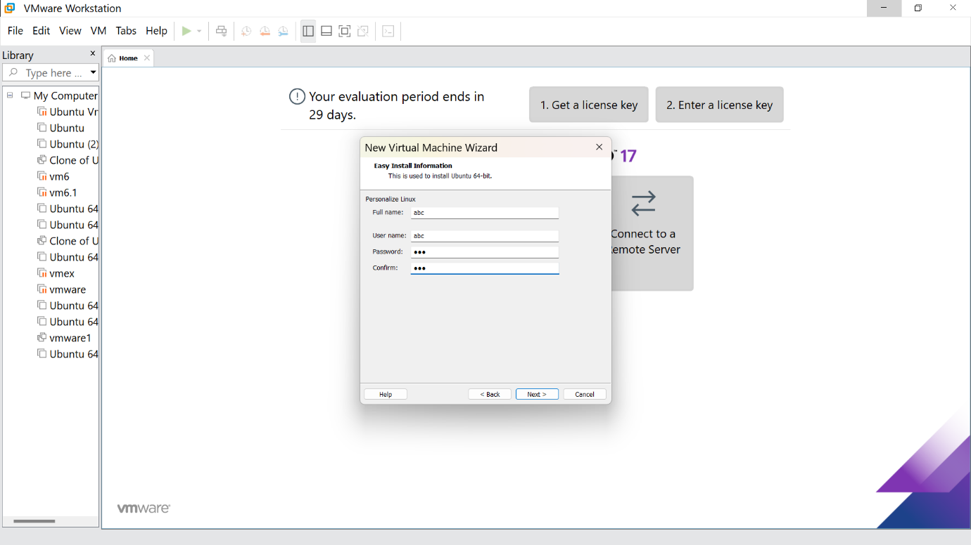

Step 6: Give the virtual machine name( as your wish)

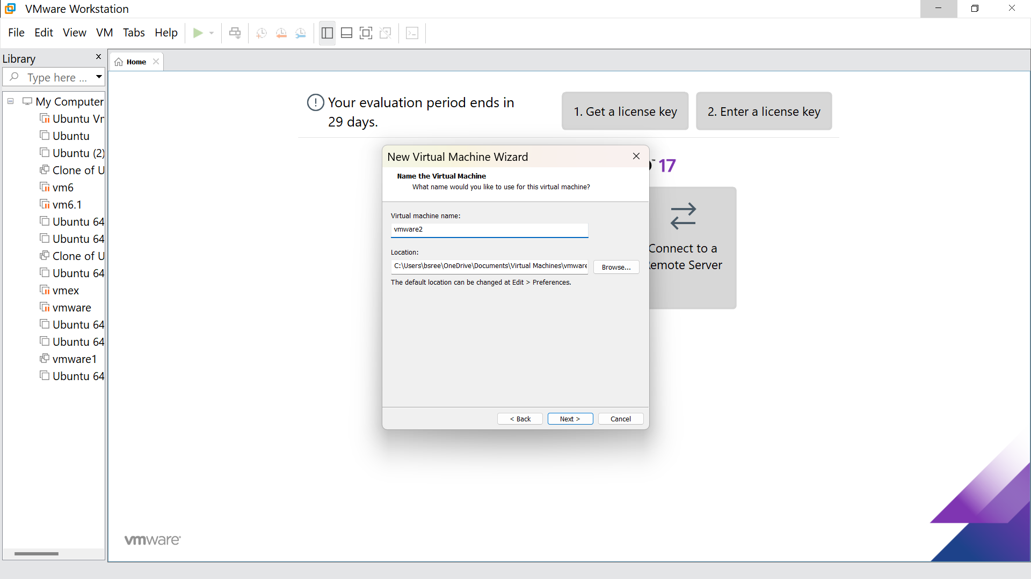

Step 7: click on ‘store virtual disk as a single file’

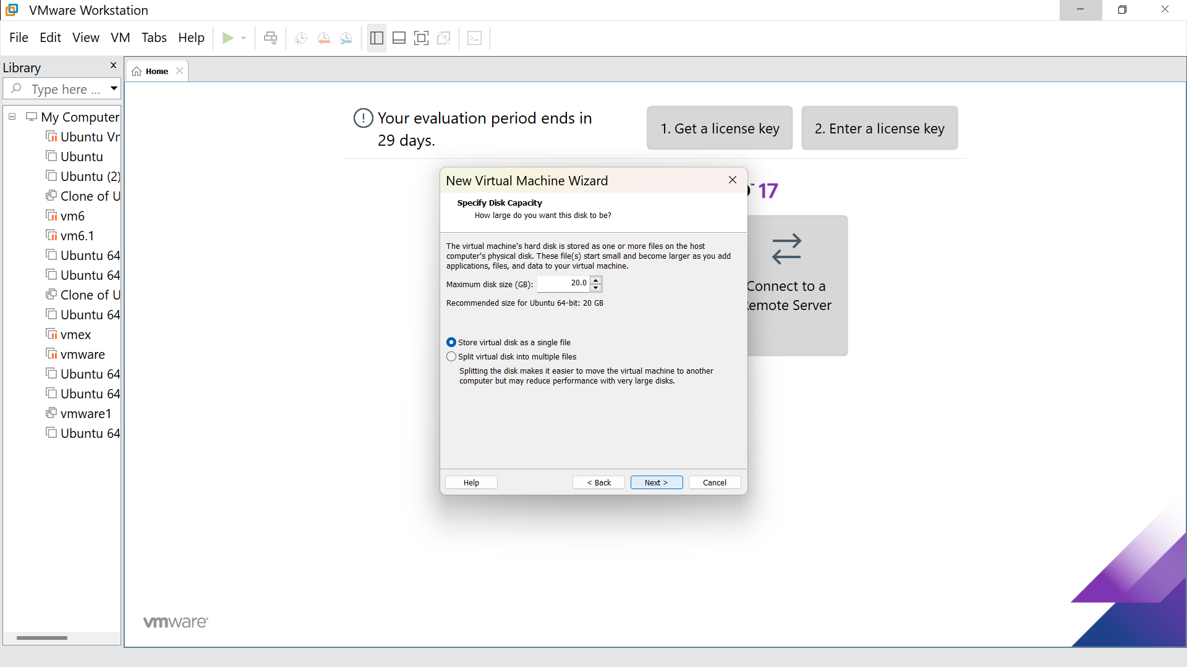

Step 8: Click on finish

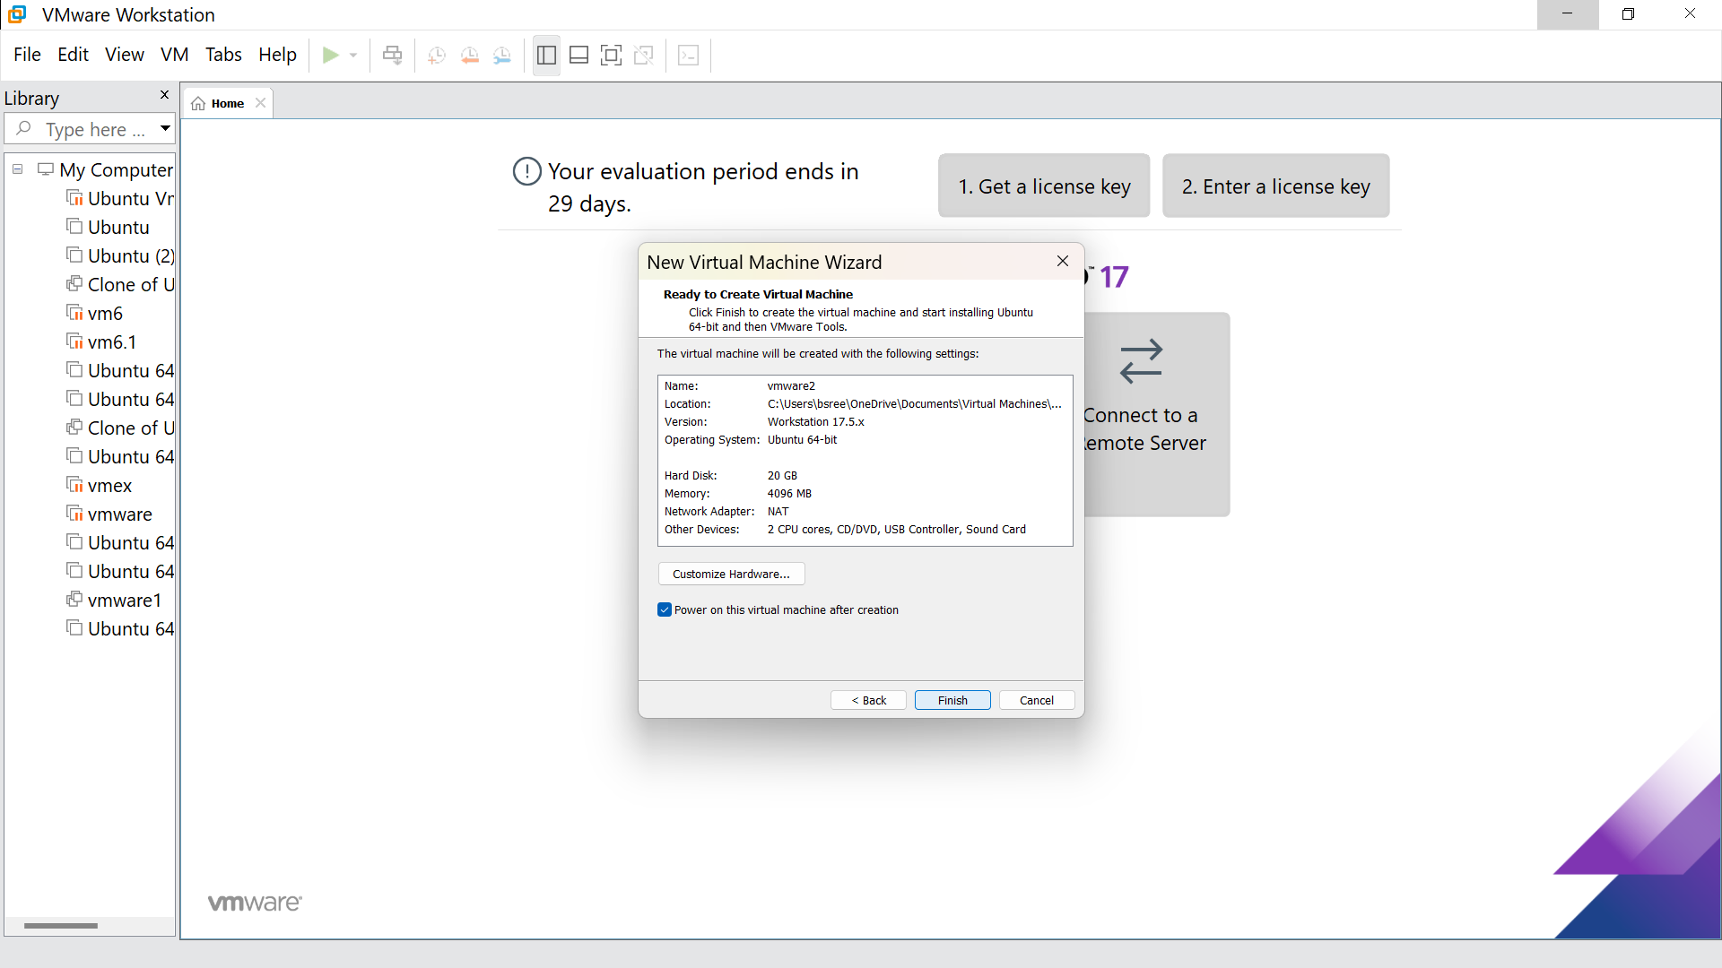

Step 9: Hence we got the output

